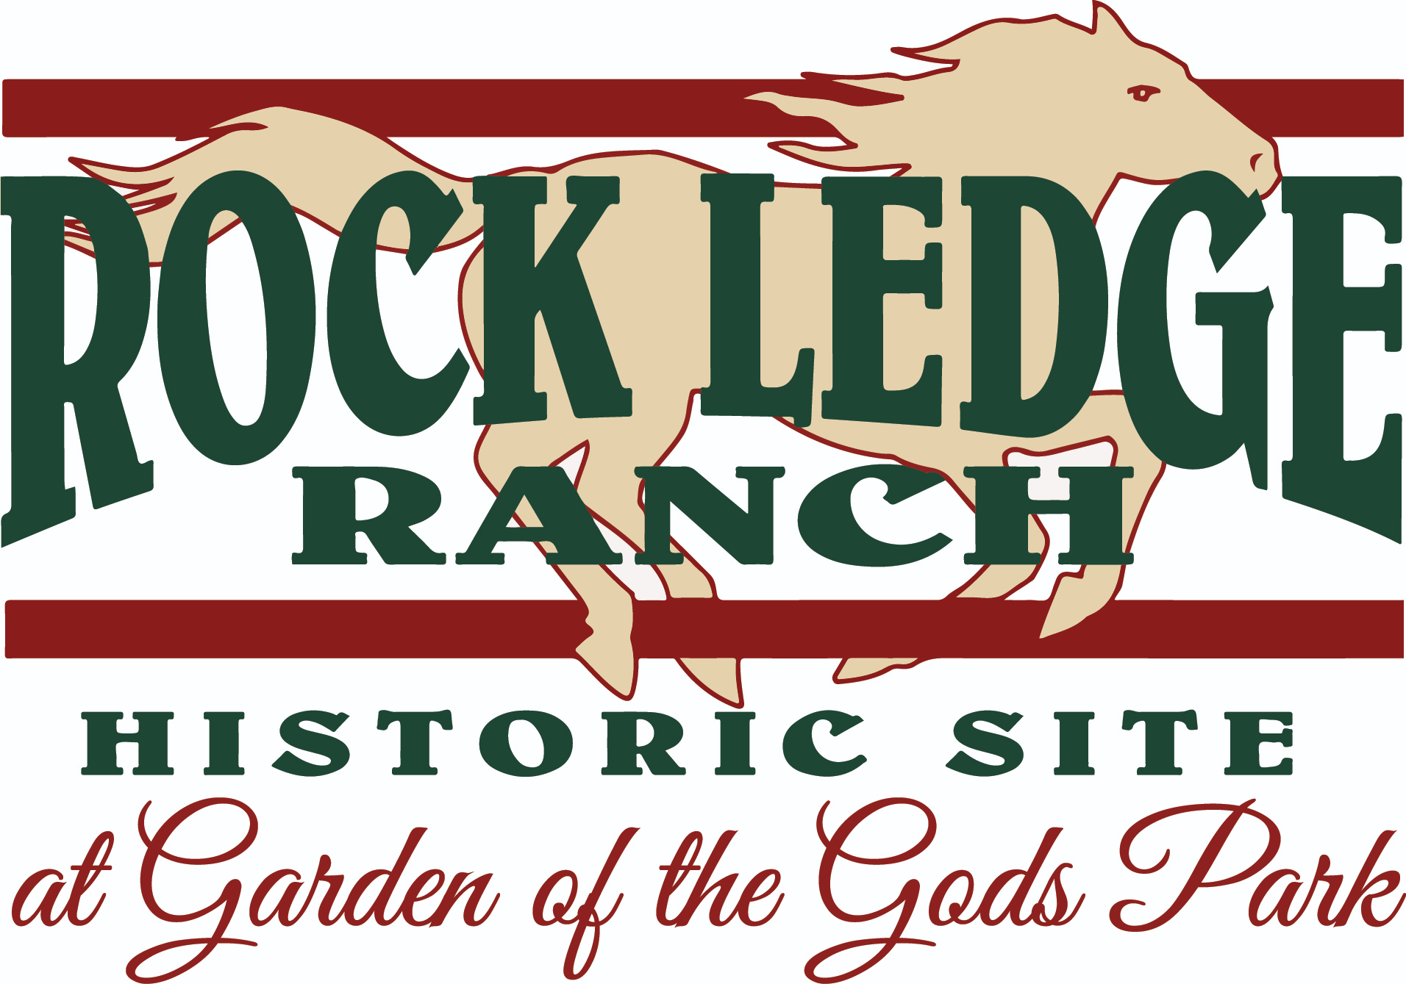
Rock Ledge Ranch Historic Site at Garden of the Gods Park
Ranch Ambassador Application: For Former JDs
Ranch Ambassadors are older youth volunteers who support seasonal interpretive staff and lead Junior Docent volunteers to further increase the effectiveness of historical interpretation and preservation at Rock Ledge Ranch Historic Site at Garden of the Gods. As youth volunteers themselves, they are under the leadership of the seasonal staff but have more responsibilities than Junior Docents.

Ranch Ambassadors are youths aged 14-20 years old who have volunteered at least one summer as Junior Docents. As Junior Docents, they have demonstrated themselves to be exemplary in the areas of historical interpretation, historical accuracy, responsibility, hard work, and leadership skills, among other character qualities. Qualified individuals will be self-motivated and disciplined individuals who can, with training, see the tasks that need to be done and do them without needing direction. They will be trustworthy and reliable, always coming to the Ranch with cheerful and ready-to-learn attitudes. Ranch Ambassadors will help lead the Junior Docents at their assigned site in conducting daily chores and routines by working alongside them and providing encouragement and guidance when necessary.

Ranch Ambassadors will be responsible for helping with community outreach which may include but not limited to interpretive programs up at the Garden of the Gods Visitor and Nature Center and in the Garden.

Ranch Ambassadors will have the opportunity to spend more time at Rock Ledge Ranch than JDs ordinarily would, working on special projects designed for Ranch Ambassadors.

Ranch Ambassadors will be asked to take ownership of certain responsibilities at their sites. They will receive training for more advanced tasks and will step into more responsibilities as staff see fit.

Ranch Ambassadors are asked to complete a research project like Junior Docents do. The Ranch Ambassador projects should be aimed at something that they can do at Rock Ledge Ranch with the staff and Junior Docents that summer. For instance, projects about activities young people would have been doing, such as games, chores, and craft projects.

Applicants can apply by filling out the Ranch Ambassador forms on the website after having submitted their applications to the Junior Docent Program in CERVIS. (For returning JDs who happen to be 18-20 years old, you may fill out the adult volunteer application in CERVIS instead.) If their application is accepted, they will be invited to interview for the position of Ranch Ambassador.

Availability:
Same as JDs, they must be able to attend the on-site training day and work at least two special events, including either Harvest Festival or Labor Day.

Applications must be typed and emailed to juniordocents@rockledgeranch.com as either a Word document or a PDF no later than March 21, 11:59PM. Any application submitted after March 21 at 11:59PM will NOT be considered for the program.

Ranch Ambassador Application
Name:
Email:

Please answer each question with a few sentences or a short paragraph.

In your own words, what is the purpose or mission of Rock Ledge Ranch?

What is something you have learned or gained from volunteering at Rock Ledge Ranch?

What sites at the Ranch have you worked at? What is something you have enjoyed at each of those sites?

Why are you interested in being a Ranch Ambassador?

What is one daily task/procedure from the site at the Ranch that you worked at last summer, and what are the steps to do it properly?

What are some traits of a good leader, and how could a person use them while volunteering at Rock Ledge Ranch?

Tell us about a time (at the Ranch or outside of it) that you saw a problem or a task and completed it without being prompted by another person.

